**Ideation Phase**

**Classiﬁcation of Arrhythmia by Using Deep Learning with**

**2-D ECG Spectral Image Representation**

**Abstract**

|  |  |
| --- | --- |
| Date | 20 September 2022 |
| Team ID | PNT2022TMID41315 |
| Project Name | Classiﬁcation of Arrhythmia by Using Deep Learningwith 2-D ECG Spectral Image Representation |
| Maximum Marks | 4 Marks |

The electrocardiogram (ECG) is one of the most extensively employed signals used in the diagnosis and prediction of cardiovascular diseases (CVDs). The ECG signals can capture the heart’s rhythmic irregularities, commonly known as arrhythmias. A careful study of ECG signals is crucial for precise diagnoses of patients’ acute and chronic heart conditions. In this study, we propose a two-dimensional (2-D) convolutional neural network (CNN) model for the classiﬁcation of ECG signals into eight classes; namely, normal beat, premature ventricular contraction beat, paced beat, right bundle branch block beat, left bundle branch block beat, atrial premature contraction beat, ventricular ﬂutter wave beat, and ventricular escape beat. The one-dimensional ECG time series signals are transformed into 2-D spectrograms through short-time Fourier transform. The 2-D CNN model consisting of four convolutional layers and four pooling layers is designed for extracting robust features from the input spectrograms.

Our proposed methodology is evaluated on a publicly available MIT-BIH arrhythmia dataset. We achieved a state-of-the-art average classiﬁcation accuracy of 99.11%, which is better than those of recently reported results in classifying similar types of arrhythmias. The performance is signiﬁcant in other indices as well, including sensitivity and speciﬁcity, which indicates the success of the proposed method.

**Keywords:**

ECG signal; classiﬁcation; arrhythmia; convolution neural network; deep learning

**Introduction :**

Cardiovascular diseases (CVDs) are the leading cause of human death, with over 17 million people known to lose their lives annually due to CVDs . According to the World Heart Federation, three-fourths of the total CVD deaths are among the middle and low-income segments of the society . A classiﬁcation model to identify CVDs at their early stage could effectively reduce the mortality rate by providing a timely treatment . One of the common sources of CVDs is cardiac arrhythmia,

where heartbeats are known to deviate from their regular beating pattern. A normal heartbeat varies with age, body size, activity, and emotions.

The electrocardiogram (ECG) recordings are widely used for diagnosing and predicting cardiac arrhythmia for diagnosing heart diseases. Towards this end, clinical experts might need to look at ECG recordings over a longer period of time for detecting cardiac arrhythmia. The ECG is a one-dimensional (1-D) signal representing a time series, which can be analyzed using machine learning techniques for automated detection of certain abnormalities. Recently, deep learning techniques have been developed, which provide signiﬁcant performance in radiological image analysis .

Convolutional neural networks (CNNs) have recently been shown to work for multi-dimensional (1-D, 2-D, and in certain cases, 3-D) inputs but were initially developed for problems dealing with images represented as two-dimensional inputs [6]. For time series data, 1-D CNNs are proposed but are less versatile when

compared to 2-D CNNs.

Hence, representing the time series data in a 2-D format could beneﬁt certain machine learning tasks [7,8]. Hence, for ECG signals, a 2-D transformation has to be applied to make the time series suitable for deep learning methods that require 2-D images as input. The short-time Fourier transform (STFT) can convert a 1-D signal into a 2-D spectrogram and encapsulate the time and frequency information within a single matrix. The 2-D spectrogram is similar to hyper-spectral and multi-spectral images (MSI), which have diverse applications in remote sensing and clinical diagnosis, including spectral un-mixing, ground cover classiﬁcation and matching, mineral exploration, medical image classiﬁcation, change detection, synthetic material identiﬁcation, target detection, activity recognition, and surveillance [9–15].

**2. Proposed Scheme**

A schematic representation of the proposed scheme is presented in Figure 1. The method consists of ﬁve steps, i.e., signal pre-processing, generation of 2-D images (spectrograms), augmentation of data, extraction of features from the data (using the CNN model), and its classiﬁcation based on the extracted features. The details of these steps are presented in the following subsections.

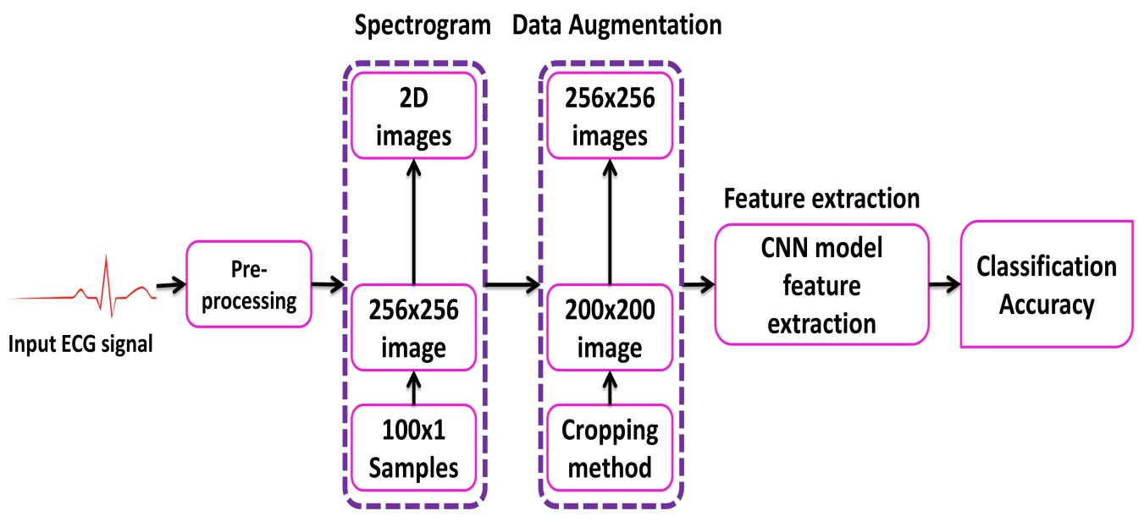

**Figure 1.** Complete procedure of electrocardiogram (ECG) signal classiﬁcation.

**Generation of 2-D Images**

# While 1-D CNN can be used for time series signals, the ﬂexibility of such models is limited due to the use of 1-D kernels. On the other hand, 3-D CNNs require a large amount of training data and computational resources. In comparison, 2-D CNNs are more versatile since they use 2-D kernels and, hence, could provide representative features for time series data. Hence, for certain applications where sufﬁcient data is available and for 1-D signals that can be represented in a 2-D format, using a 2-D CNN could be beneﬁcial. Herein, for generating 2-D images to be used with the 2-D CNN model, the ECG signal was transformed into a 2-D representation. The 2-D time-frequency spectrograms were generated using the short-time Fourier transform. The 1-D ECG signals were converted into 2-D spectrogram images by applying STFT as follows,

# X ST F T [m, n] =L−1∑ x[k] g[k − m]e − j2π nk/ L (2)

# k=0 where L is the window length, and x [k] is the input ECG signal. The log values of XS T F T [m, n] are represented as spectrogram (256 × 256) images.

**3. Experiments**

**Dataset:**

# The MIT-BIH arrhythmia dataset consists of 48 records, each having an approximate duration of 30 min recorded from a two-channel ambulatory system, collected between 1975 and 1979 [50]. Twenty-three recordings were selected at random from 4000 long term Holter recordings composed of a diverse group of inhabitants of indoor patients (60%) as well as outdoor patients (40%). Twenty-ﬁve recordings were chosen from a similar set, with a focus on complex ventricular, junctional, and supra-ventricular arrhythmias. These recordings were digitized at 360 samples/sec for each channel with a resolution of 11-bits over a range of 10 mV. A minimum of two cardiologists were involved in annotating each record and recorded the issues and corresponding solutions needed to reach to the computer-readable outcome. Hence, for the records, approximately 110,000 explanations were documented in this database. The data is publicly available for download here: https://www. physionet.org/content/mitdb/1.0.0/.

**Deep Neural Network Parameters:**

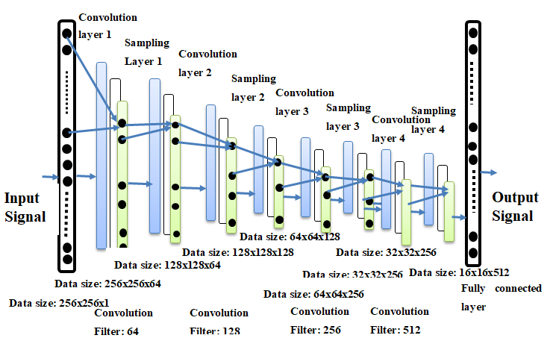

**Classiﬁcation Results:**

The two signiﬁcant optimization parameters in the proposed 2-D CNN model are the learning rate and the batch size of the data used. To improve the performance, these two optimization parameters must be selected carefully to obtain the best accuracy in the automatic classiﬁcation of arrhythmia using the ECG signals. The proposed model was evaluated in different experiments with various values of learning parameters. For a smaller value of the learning rate (i.e., less than 0.0005), the speed of the convergence was very slow. However, when the value of the learning rate was large (i.e., greater than 0.001), the speed of convergence improved. At the same time, asymmetrical changes were observed in the accuracy rate. Henceforth, we selected an optimum value of 0.001 for the learning rate, as this value can attain better accuracy for the proposed model (i.e., optimum value).

Similar to the learning rate, the batch size of the data also greatly affected the behavior and accuracy of the model. When the batch size was chosen to be 1000, the accuracy of the system showed abnormally large ﬂuctuations in terms of system convergence. When the batch size was set to 2000, the accuracy of the system increased but did not reach a stable state. When the batch size was further increased to 2800, the accuracy of the proposed model was the highest and reached a stable state.

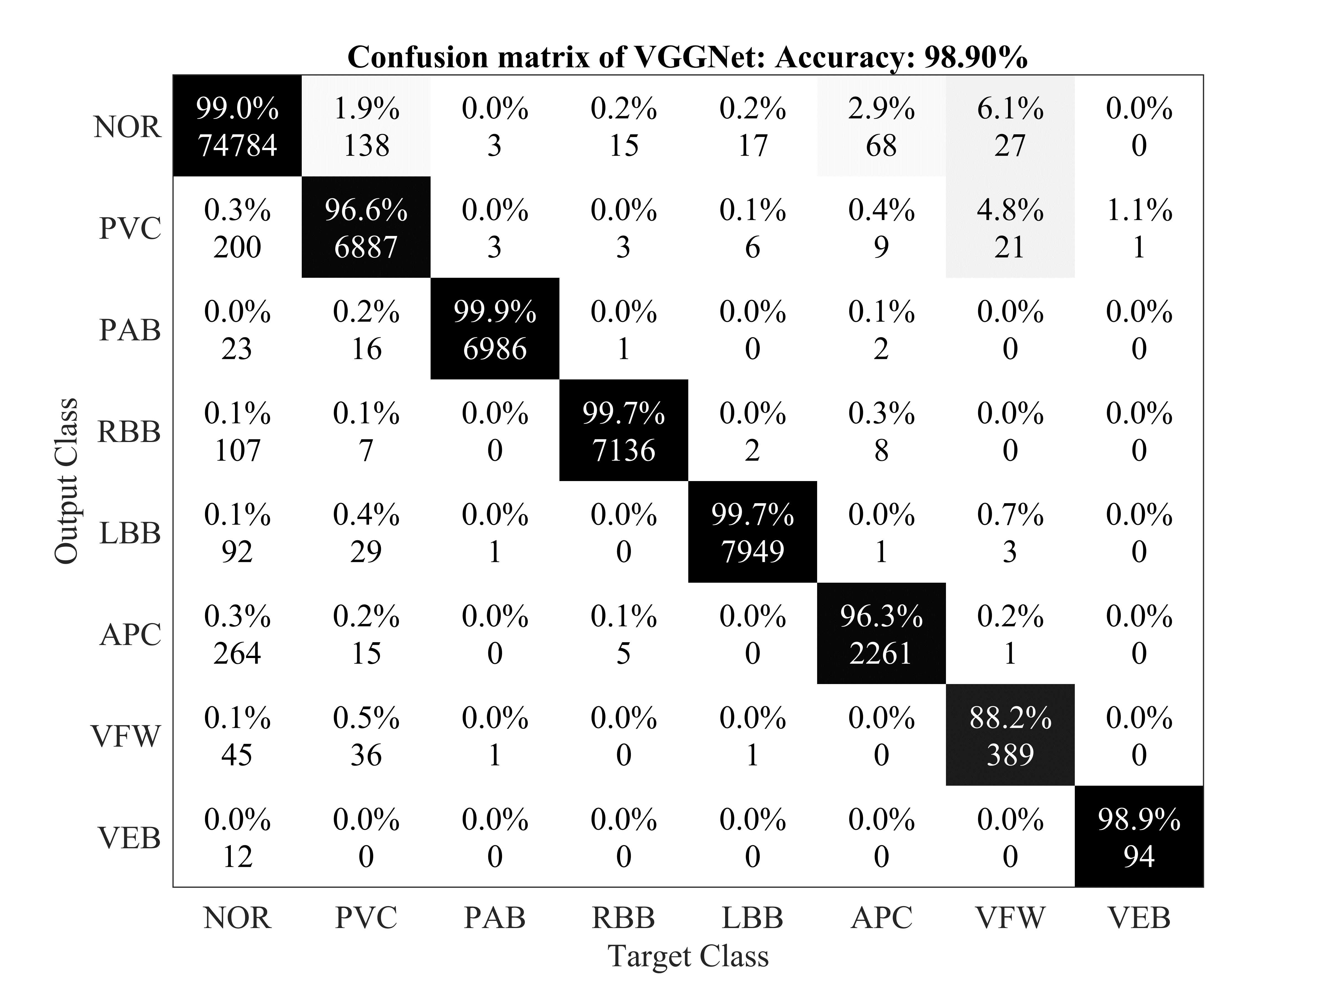

**Figure 3.** Confusion matrix for VGGNet.

**4.2. Discussion**

Table 4 summarizes the performance evaluation of the proposed CNN algorithm with other classiﬁcation methods of arrhythmia using ECG signals. The terms ’native’ and ’augmented’ in Table 4 represent the training set without and with data augmentation, respectively. However, a direct comparison of our proposed CNN model with existing techniques may be unﬁt due to variations in the training and testing dataset, size of the ECG dataset used for experiments, architecture of the CNN models used, and the varying number of types of arrhythmia used for classiﬁcation. It should be noted that there are various methods that used 1-D data directly for the classiﬁcation of arrhythmia [52–58]. Among these methods, 1-D CNN models have been proposed with a lower classiﬁcation accuracy ([56]—96.40% and [58]—93.60%) when compared with the proposed model. We also used 1-D ECG signals as input to the CNN model used in experiments and achieved a classiﬁcation accuracy of97.80%. In recent years, 2-D CNN models have also been used, by converting the 1-D ECG signals to 2-D representation, with noticeable performance [16]. Towards this end, the proposed model was based on a 2-D representation of the ECG data to efﬁciently apply 2-D CNN models and beneﬁt from

the ﬂexibility of data augmentation in such methods.

The proposed 2-D CNN model attained better accuracy, sensitivity, and speciﬁcity (in eight class classiﬁcation) than the FFNN [59] model, which classiﬁed only four kinds of arrhythmia. It was observed that the VGGNet model performs worse than the proposed model, albeit a deeper network. One of the reasons for these observations could be the deeper architecture of VGGNet and limited training data. These results prove that the proposed CNN model has the state-of-the-art accuracy for the automatic classiﬁcation of arrhythmia based on the comparison with different CNN based algorithms. Varying performance among the compared CNN models is due to the difference in their architectures and the number of convolution ﬁlters used in these CNN models’ structures. In the proposed CNN model, we employed four convolutional layers, four downsampling (pooling) layers, and one fully connected layer. In the AlexNet model, six convolutional layers, three downsampling layers, and two fully connected layers were used, while the VGGNet model entailed ten convolutional layers, four down sampling layers, and two fully connected layers. By adding a convolutional or a down sampling layer to the architecture of the CNN models, the computational resources and the simulation time for training and testing the models also increase, and this is the main reason for using a carefully selected CNN model. Since we have a limited amount of data, more deeper networks (such as DenseNet or ResNet) would not qualify to perform well within the scope of this problem.

# Conclusion

# In this study, we proposed a 2-D CNN-based classiﬁcation model for automatic classiﬁcation of cardiac arrhythmias using ECG signals. An accurate taxonomy of ECG signals is extremely helpful in the prevention and diagnosis of CVDs. Deep CNN has proven useful in enhancing the accuracy of diagnosis algorithms in the fusion of medicine and modern machine learning technologies. The proposed CNN-based classiﬁcation algorithm, using 2-D images, can classify eight kinds of arrhythmia, namely, NOR, VFW, PVC, VEB, RBB, LBB, PAB, and APC, and it achieved 97.91% average sensitivity, 99.61% speciﬁcity, 99.11% average accuracy, and 98.59% positive predictive value (precision). These results indicate that the prediction and classiﬁcation of arrhythmia with 2-D ECG representation as spectrograms and the CNN model is a reliable operative technique in the diagnosis of CVDs. The proposed scheme can help experts diagnose CVDs by referring to the automated classiﬁcation of arrhythmia with 2-D ECG representation as spectrograms and the CNN model is a reliable operative technique in the diagnosis of CVDs. The proposed scheme can help experts diagnose CVDs by referring to the automated classiﬁcation ofBB, LBB, PA ECG signals. The present research uses only a single-lead ECG signal. The effect of multiple lead ECG data to further improve experimental cases will be studied in future work.